# Moringa oleifera can help treat diabetes, study finds - NaturalNews.com

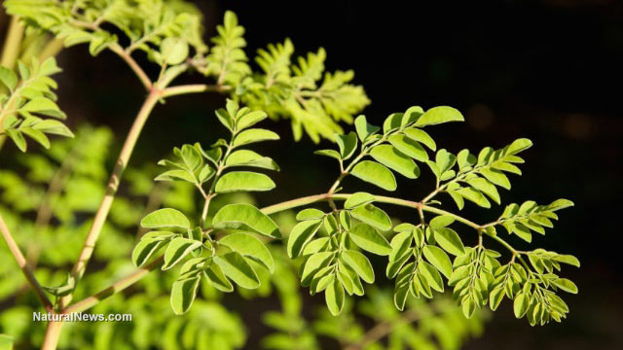 Moringa oleifera can help treat diabetes, study finds

Thursday, April 24, 2014 by: Michael Rave

Tags: Moringa, diabetes, glutathione

(NaturalNews) The leaves of the *Moringa oleifera* tree are one of Asia's most nutrient- dense foods. In fact, just one serving of these leaves in powdered form contains almost 50 types of antioxidants and almost 90 different nutrients. Unsurprisingly, numerous studies have linked long-term consumption of *Moringa* leaves to the treatment of countless health conditions such as osteoporosis, macular degeneration, high blood pressure, obesity and even cancer.

A recent study published in the March 2014 issue of *Acta Histochemica*, however, suggests that we add another condition to that list: diabetes mellitus, the increasingly common metabolic disease that affects an estimated 8.3 percent of the United States population.

## Significant results

For the study, the Egyptian researchers fed aqueous extracts of *Moringa oleifera* leaves to albino rats that were suffering from streptozotocin-induced diabetes. During the trial period, they monitored the fasting plasma glucose levels of the rats, as well as their levels of glutathione (an antioxidant found in *Moringa* that contains antidiabetic properties) and malondialdehyde (a toxic byproduct of lipid oxidation that is often found in high levels in people suffering from diabetes).

At the end of the trial, the rats that were fed *Moringa* extracts fared far better than the control group. Specifically, the extracts reduced their fasting plasma glucose levels from 380 percent to 145 percent (i.e. their blood sugar levels were reduced by more than 2.5 times). The extract also reduced the rats' levels of harmful malondialdehyde from 385 percent to 186 percent and increased their levels of the important antioxidant, glutathione, from 22 percent to 73 percent -- a significant improvement in all three areas.

"Experimental findings clearly indicate the potential benefits of using the aqueous extract of *M. oleifera* leaves as a potent antidiabetic treatment," the researchers concluded.

## Discerning Moringa products

Word about the "Miracle Tree" of the Himalayas has spread fast in the West during the last decade, and the natural health market is now saturated with *Moringa* powders, tinctures and oils. Though the manner in which *Moringa* is consumed isn't important, it is important that the product is (a) certified organic, and (b) wildcrafted, meaning that it has been harvested from the wild. Most *Moringa* products meet these criteria, but sadly some of the trees (particularly those grown in China) are now being sprayed with pesticides.

**Sources for this article include:**

<http://diabetes.niddk.nih.gov>

[http://www.ncbi.nlm.nih.gov/](http://www.ncbi.nlm.nih.gov/pubmed/24657072)

<http://science.naturalnews.com> <http://truthwiki.org/Natural_Help_for_Diabet>...

**About the author:**

Michael Ravensthorpe is an independent writer whose research interests include nutrition, alternative medicine, and bushcraft. He is the creator of the website, Spiritfoods, through which he promotes the world's healthiest foods.

**More news on Moringa**

Moringa plays an important role for breastfeeding mothers, in diabetes, in cancer, and more: <http://www.naturalnews.com/034976_moringa_breastfeeding_diabetes.html>

Discover the many health benefits of Moringa, the ultimate survival 'superfood': <http://www.naturalnews.com/037735_Moringa_superfood_health_benefits.html>

The many health benefits of Moringa oleifera: <http://www.naturalnews.com/042435_Moringa_oleifera_health_benefits_herbal_medicine.html>

Moringa oleifera is a potent anti-inflammatory, study finds: <http://www.naturalnews.com/043310_Moringa_oleifera_anti-inflammatory_herbal_medicine.html>

Grow your own "miracle tree" and enjoy a natural medicine chest and hearty source of survival food rolled into one: <http://www.naturalnews.com/042122_moringa_tree_natural_medicine_survival_food.html>

Health benefits of superfood moringa: <http://www.naturalnews.com/043171_moringa_food_source_health_benefits.html>

The moringa is a miracle tree that is being promoted as a solution to Third World malnutrition: <http://www.naturalnews.com/044642_moringa_miracle_tree_malnutrition.html>

Source: <http://www.naturalnews.com/046486_Moringa_diabetes_glutathione.html>