# Moringa and Blood Sugar

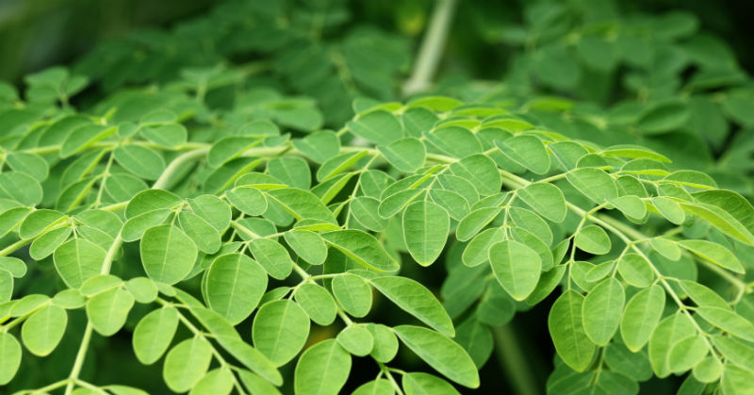

Moringa Oleifera is a natural-growing plant that has been used to treat a variety of medical conditions for thousands of years. If you are just now hearing about it as a potential supplement to help maintain normal blood sugar, that is due modern technology. Plants like Moringa have traditionally been limited to the people living near their natural habitats. Manufacturers are now bringing these plants to other areas of the world due to advanced harvesting, collection, processing and shipping methods.

Some plants, berries and fruits coming from different regions of the world turn out to be nothing but fads, particularly in the weight loss industry. These supplements are easy to identify because they are backed by little to no scientific research, and anecdotal accounts of their benefits cannot be verified or proven. Since dietary supplements do not need to be pre-approved by the FDA before they hit store shelves in the United States, many people are confused about the products they consume and the benefits they may derive from taking them. FDA enforcement includes this area and the presentation of unsafe products.

If your hopes are high for adding Dead Sea Moringa to help keep your blood sugar in the normal range, you are in luck. This supplement stands apart from the fads in multiple ways:

1. There have been many scientific studies indicating the benefits of Moringa supplementation. These are official, controlled studies from reputable researchers around the world.
2. The scientific evidence in favor of the supplement backs up the anecdotal accounts from real people around the world. You don’t have to question the success stories you read online as being fabricated by marketers because there is researching proving that those success stories have been replicated in controlled environments.
3. Moringa has been used as a nutritional supplement for malnourished people in some of the poorest regions of the world. Humanitarian groups were using the supplement to help pregnant and nursing women increase their milk supply and malnourished children increase their appetites long before the supplement hit the mass market in the western world.
4. The supplement is not marketed as a cure for diabetes or any other medical condition. It is a nutritional supplement that happens to help maintain normal blood sugar levels and support blood circulation. It has also been found to help maintain normal blood pressure levels and to be of benefit in a variety of bodily systems.
5. It is the overall nutritional profile that makes Moringa a powerful supplement to keep the human body healthy. Many berries and plants that end up being fads have just one natural property that supposedly gives them healing power for one or two specific applications.  While other supplements have one vitamin or nutrient, Dead Sea Moringa is a full complex of nutrients.

It is difficult to find natural supplements that have this many potential applications backed by scientific evidence. The evidence is key because so many supplements have no evidence at all. They force you to risk your health by taking a product that may help you in the short term while hurting you in the long term. Moringa supplements have been used widely around the world for many years, and to date, there are no known side effects. You can actually find more supporting scientific evidence in favor of the supplement than you can find reports of negative experiences.

This makes it an all-natural supplement that is safe for most people to add to their diabetes treatment plans. You may want to discuss your use of the supplement with your doctor if you take prescription medications, but start with a quick analysis of the research supporting its use.

## An Overview of the Research

There are a few things you need to understand about scientific studies researching the use of Moringa supplements to treat diabetes or any other medical condition:

1. Each study uses a different part of the plant with different processing requirements. For instance, some studies use Moringa seeds while others use a powdered form of the leaves.
2. Each study specifies a specific dose of the supplement to be administered on a routine schedule. Therefore, the results delivered are based on consuming a specific dose at specific intervals over a given period of time.
3. Some studies are on rats, but more human studies are starting to surface. It is clear that the research on humans will continue in the years to come. Where we are today is just the beginning for discovering the full benefits of Moringa supplements.

In May 2007, the [Journal of Clinical Biochemistry and Nutrition](http://www.ncbi.nlm.nih.gov/pmc/articles/PMC2275769/) released the results of a controlled study analyzing the effects of Moringa on blood glucose tolerance in rats. Fresh Moringa Oleifera leaves were collected in Senegal , which is a natural habitat for the plant. A powder was created from shade-dried leaves, and the powder was used as a supplement for one group of rats.

Researchers used a control group and fed both groups of rats the same food and water to eliminate other influences on glucose tolerance. The results of this study showed that the rats consuming the Moringa powder did show signs of improved glucose tolerance over rats in the control group.

In February 2011, the [International Journal of Health & Nutrition](http://asciencejournal.net/asj/index.php/IJHN/article/view/68/pdf_27) released information from a study that allowed human patients to take a Moringa leaf supplement for a period of three months. These patients were monitored for blood glucose level changes after each month of supplementation. The study used leaves from the Moringa plant formed into “dehydrated green leafy tablets,” also known as drumstick leaf tablets. The results of the study showed that the patients did lower their blood glucose levels each month of supplementation, with the most significant drop in levels occurring in the third month of supplementation.

## Can Moringa Oleifera Cure Diabetes?

Studies do not claim that Moringa supplements can cure diabetes or any other medical condition. Research has confirmed that the nutritional profile of the plant is beneficial for a variety of human bodily systems and functions, but it is used as a supplement rather than a treatment.

Dead Sea Moringa can help maintain normal blood sugar levels along with following additional benefits:

* Weight Loss Support
* Enhanced Nutrition
* Maintain Normal Blood Glucose Levels
* Support Normal Blood Pressure

There are many real-world cases where diabetics have reversed their condition through enhanced nutrition, exercise and extensive weight loss. This makes sense, considering the number of people who become diabetic due to obesity, sedentary lifestyles and unhealthy eating habits. When those factors are turned around, some people can take charge of their health.

While it is not marketed as a cure for diabetes, Moringa supplements can help support weight loss and will definitely help nourish your body with high-quality nutrients, vitamins, minerals and antioxidants. You still have to do the work by controlling your daily diet and living a more active lifestyle.

These statements have not been evaluated by the Food and Drug Administration. This product is not intended to diagnose, treat, cure or prevent any disease.

**© 2014 DEAD SEA MORINGA**

Source: <http://www.deadseamoringa.com/benefits/moringa-leaf-diabetes/>