# Moringa Oleifera Leaf Powder -- Nutritional Analysis

Site Network: Moringa Leaf Powder Moringa Trees Moringa Seeds Mountain Cottage Struisbaai House Beljohn Dean's Art

* Moringa Leaf Powder * Nature's Most Nutritious Vegetable PowerFood *

## NUTRITIONAL ANALYSIS OF MORINGA LEAF POWDER

**% RDA Provided by 30 Grams of Moringa Leaf Powder**

|  |  |  |
| --- | --- | --- |
| Calcium | 601 mg | 60 % |
| Magnesium | 110.4 mg | 37 % |
| Iron | 8.46 mg | 84 % |
| Copper | 0.171 mg | 19 % |
| Potassium | 397.2 mg | 11.3 % |
| Phosphorus | 61.2 mg | 9% |
| Vitamin A | 4.89 mg | 163 % |
| Vitamin B1 | 0.792 mg | 52.8% |
| Vitamin B2 | 6.15 mg | 361 % |
| Vitamin B3 | 2.46 mg | 13 % |
| Vitamin C | 5.19 mg | 8.6 % |
| Vitamin E | 33.9 mg | 226 % |
| Protein | 8.1 grams | 12.8 % |

**And thats just 30 grams!**

**Remember that many people are mal-nourished even if they 'eat well'. Especially if one considers how essential nutrients are destroyed and damaged during cooking and processing.**

**Adding just 30 grams to your daily diet can make all the difference between being well-nourished and mal-nourished.**

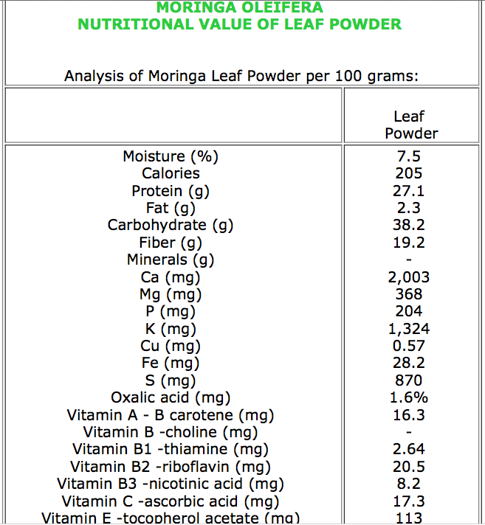

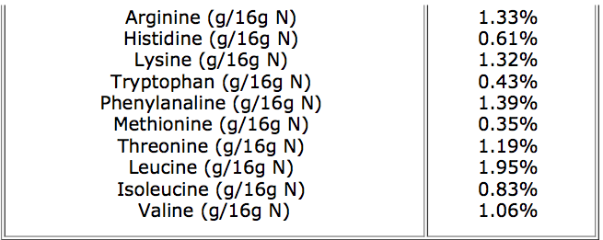

If every household had access to Moringa then malnutrition would be wiped out. Wealthier Households would have no need to purchase artificial supplements.

Remember that most tablet supplements contain 'artificially manufactured' vitamins and minerals. Much of the Vitamin C in so-called vitamin tablets for example is synthesised from Genetically Modified Soya Beans and is far removed from anything that the body can utilise. Similarly, Minerals supplements are often sourced from questionable industrial processes and can lead to calcification rather than effective utilisation.

Everything in Nature works in symphony - a synergy achieved through the subtle interactions of many components and not just one so-called active 'isolated' ingredient.

All the Nutrients in Moringa Leaf Powder are **BIO CHELATED** which means they are in their natural form as part of the leaf's cellular structures and is therefore most suitable for absorption and utilization by the Human Body.

## Who would You rather Trust? Nature or Industry?

**MORINGA LEAVES**

Dr. Frank Martin states in 'Survival and Subsistence in the Tropics' that "among the leafy vegetables one stands out as particularly good, the Horseradish Tree. The leaves are outstanding as a source of Vitamin A and Vitamin C .

They are a good source of B Vitamins and amoung the best plant sources of Minerals. The Calcium content is very high for a plant. Phosphorus is low, as it should be.

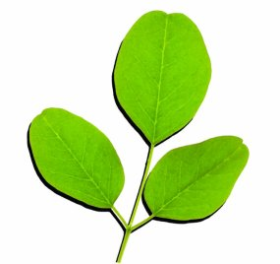

The content of Iron is very good (it is reportedly prescribed for anemia in the Phillipines).

They are an excellent source of Protein and a very low source of fat and carbohydrates. Thus the leaves are one of the best plant foods that can be found."

In his 'Edible Leaves of the Tropics', he adds that the Leaves are incomparable as a source of the sulphur-containing amino acids methionine and cystine, which are often in short supply.

## The following figures reflect Gram-for-Gram Comparisons with Moringa Leaf Powder:

Proteins, the building blocks of our bodies, are made of amino acids. Usually, only animal products such as meat, eggs and dairy contain all of the essential amino acids. Amazingly, Moringa leaves also contain all the essential amino acids required for Human Protein Synthesis.

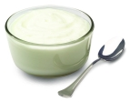 **8 ½ times the Protein of Yogurt**

Potassium is essential for the brain and nerves. Bananas are an excellent source of potassium. Moringa leaves are even better.

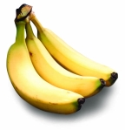**15 times the Potassium of Bananas**

Vitamin A acts as a shield against diseases of the eyes, skin and heart, diarrhea, and many other ailments. Carrots are

very high in vitamin A, but Moringa leaves are even higher.

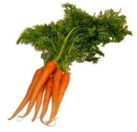**10 ½ times the Vitamin A of Carrots**

Iron is necessary for many functions in the body including formation of haemoglobin, brain development and function, regulation of body temperature and muscle activity. Lack of iron directly affects the immune system;; it diminishes the number of T-Cells and the production of antibodies. Besides haemoglobin, iron is a component of myoglobin, the cytochromes, catalase and certain enzyme systems. Iron is essential for binding oxygen to the blood cells. The central function of iron is oxygen transport and cell respiration. Spinach is high in Iron, Moringa has even more.

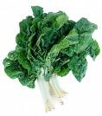**12 times the Iron of Spinach (leaf powder)**

Calcium builds strong bones and teeth, and helps prevent osteoporosis. Milk provides a lot of calcium, but Moringa leaves provide even more.

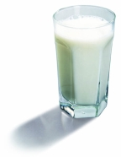**16 ½ times the Calcium of Milk (leaf powder)**

**NUTRIENT COMPARISONS PER 100 GRAMS**

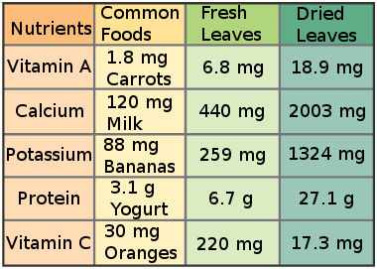

Moringa Oleifera: Natural Nutrition for the Tropics by Lowell Fuglie

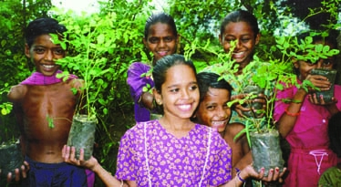"For a child aged 1-3, a 100 g serving of fresh leaves would provide all his daily requirements of calcium, about 75% of his iron and half his protein needs, as well as important amounts of potassium, B vitamins, copper and all the

essential amino acids. As little as 20 grams of leaves would provide a child with all the vitamins A and C s/he needs."

"For pregnant and breast-feeding women, Moringa leaves and pods can do much to preserve the mother's health and pass on strength to the fetus or nursing child. One 100 g portion of leaves could provide a woman with over a third of her daily need of calcium and give her important quantities of iron, protein, copper, sulfur and B-vitamins."

"One rounded tablespoon (8 g) of leaf powder will satisfy about 14% of the protein, 40% of the calcium, 23% of the iron and nearly all the vitamin A needs for a child aged 1-3. Six rounded spoonfuls of leaf powder will satisfy nearly all of a woman's daily iron and calcium needs during pregnancy and breast-feeding."

During pregnancy and breast-feeding, women are most at risk of suffering from nutritional deficiencies.

The table below shows the percent of the RDA of various nutrients for a nursing mother eating six rounded tablespoons (about 50 g) of leaf powder daily. It also shows the percent of the RDA for a 1-3 year old child with one rounded tablespoon of powder added to its food, three times daily.

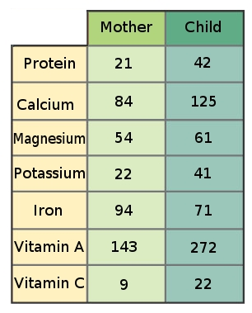

From Moringa Oleifera: Natural Nutrition for the Tropics by Lowell Fuglie

Source: <http://www.moringaleafpowder.co.za/analysis.html>