MORINGA LEAF POWDER

Moringa leaves are one of the richest sources of Vitamins, Minerals and Amino Acids. India's ancient tradition of Ayurveda says the leaves prevent 300 diseases.

*Moringa Leaf Powder is a SuperFood - consumed as a fresh vegetable the world over as a rich source of nutrition.*

*It is one of the richest plant sources of protein, calcium and potassium, as well as, vitamins A, C, E and B-Complex!*

The leaves of the Moringa Oleifera tree are a natural source of energy offering support for the immune system, bursting with high levels of naturally occurring antioxidants. Nutritional analysis shows that Moringa leaves are very high in protein.

Traditional medicine in several countries has used these leaves to cure a host of diseases. India's ancient tradition of Ayurveda says the leaves of the Moringa tree prevent 300 diseases. The Ayurvedic Medicine of India has many uses for Moringa tree products;; such as a natural antibiotic, an aid in childbirth, for treating liver disorders, in tea as a powerful cold remedy, among others.

It has been shown that 25 grams daily of Moringa Leaf Powder will provide you with the following recommended daily allowances:

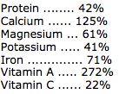

Mixed with honey and followed by a drink of coconut milk 2 or 3 times a day, leaves have been used traditionally as a remedy for diarrhea, dysentery and colitis.

Ingredients: 100% Organic Moringa leaf powder

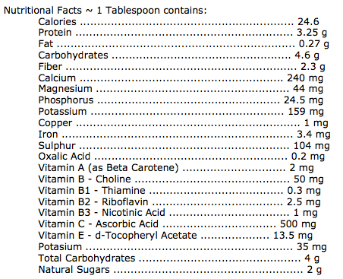

Other Known Nutrients: Arginine, Histidine, Lysine, Phenylananine, Methionine, Theonine, Leucine, Isoleucine and Valine.

Contains no added sugar, artificial colors or artificial flavors.

Suggested Use: Mix 1/2 to 1 heaping teaspoon Moringa Leaf Powder in 8oz of water or juice of your preference daily or as directed by your healthcare professional.

Warning: If pregnant, nursing or taking any medication, consult your healthcare professional before taking this product.

These statements have not been evaluated by the Food & Drug Administration. This product is not intended to diagnose, treat, cure or prevent any disease. Be sure to check with your health care professional before taking any dietary supplement.

   

Source: Hilery Owens, <http://www.healthyitems.com/MORINGA-LEAF-POWDER-p/111.htm>