How to Benefit from the Healing Power of Moringa Plus a Moringa Superfood Smoothie



**How to Benefit from the Healing Power of Moringa Plus a Moringa Superfood Smoothie**

by deborah on April 3, 2014 · 4 comments

in Green smoothies, Nourish, Raw Food Diet, Vegan

<http://urbannaturale.com/how-to-benefit-from-the-healing-power-of-moringa-plus-a-moringa-superfood-smoothie>



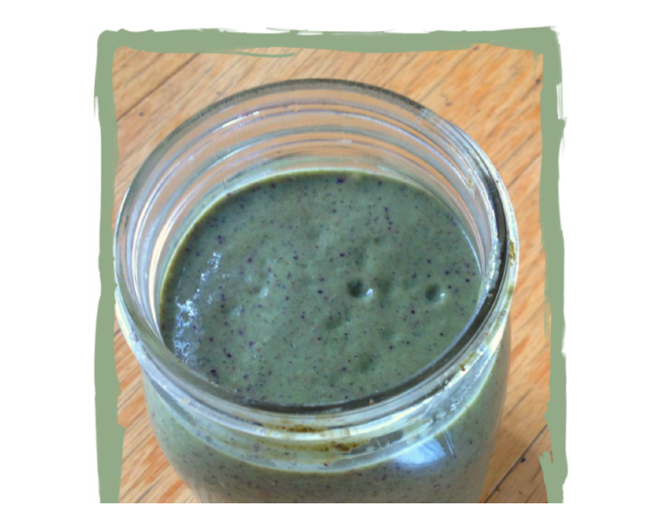

While on a tour in Honduras, local herbal medicine men demonstrated some of the medicinal plants that were commonly grown there and used for natural healing. We tasted a variety of brown, bitter brews, tonics and teas. One of them was moringa tea–a plant I was not familiar with at the time.

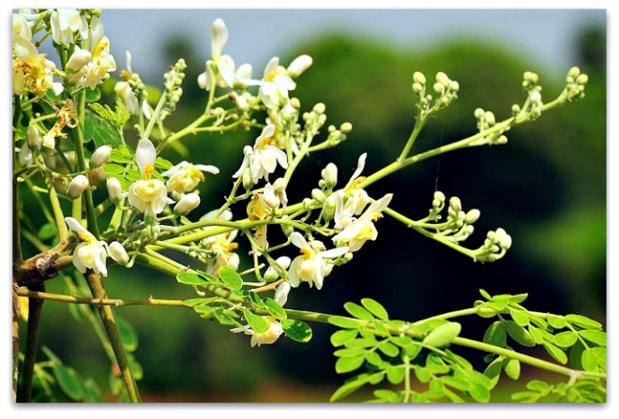

Photo: Moringa Tree. Source:

The herbalists extolled the virtues of moringa so fervently that I bought a bag of the dried green leaves, brought it and stowed it away in my pantry for a year. I forgot about that strange-looking package of leaves until recently. While exploring booth after booth of health and nutritional products at the New Life Expo, I ran into a vendor who was explaining the many health benefits of moringa to another attendee. I stopped and asked for more information and he told me that moringa was considered one of the most nutrient-dense plants ever discovered.

## Health Benefits of Moringa Leaf Powder

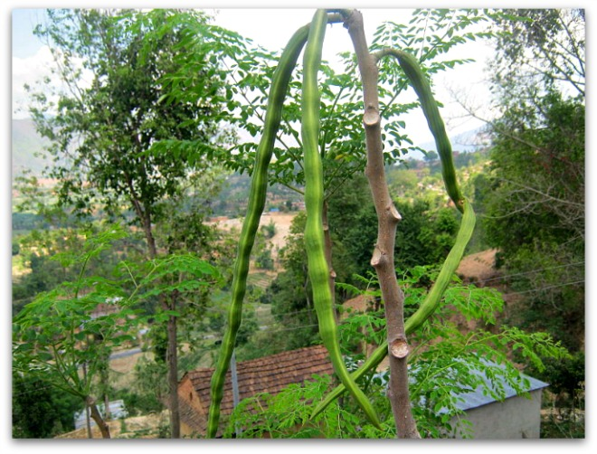

Photo: Moringa Tree with Pods. Source:

When he mentioned that moringa leaf powder provided significant amounts of protein, he really had my attention.

What’s more, he explained that it’s documented health benefits included:

**\*Rapid improvements in energy and endurance**

**\*Mental clarity**

**\*Lowers blood sugar levels for diabetics**

**\*Lowers blood pressure**

**\*Lowers cholesterol**

**\*Balances hormones**

**\*Boosts immune system**

**\*Detoxifies the body**

**\*Antibiotic, anti-inflammatory, anti-parasitical properties**

**\*Relieves constipation**

**\*Serves as a diuretic**

**\*Relieves skin problems**

**\*Improves eyesight**

**\*Assists with sleep**

**\*Supports hair health and growth**

**\*Heals cuts and wounds**

**\*Helps treat depression**

**\*Treats minor infections**

**\*Improves appearance of skin**

I am a pretty healthy gal, but I often still experience a lack of energy and often have trouble sleeping so I left there with a bag of moringa leaf powder to try out at home. Determined to learn more about this mysterious superfood, I researched moringa and learned a lot more about it.

## Impressive Source of Nutrients

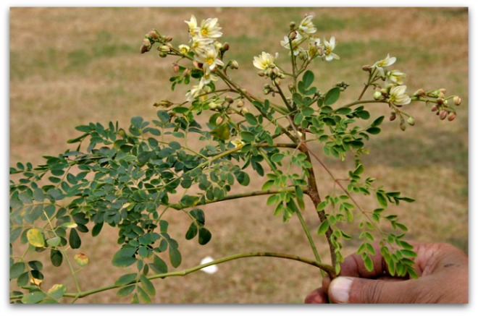

A powerful source of nutrients, moringa is grown mainly in semi-arid, tropical, and subtropical areas. Photo source:

Moringa oleifera is a fast growing, evergreen, deciduous tree grown mainly in semi-arid, tropical, and subtropical areas. The leaves are the most nutritious part of the plant, being a significant source of B vitamins, vitamin C, vitamin A as beta-carotene, vitamin K, manganese and protein, among other essential nutrients.

Moringa leaves contain 20 types of amino-acids, 46 antioxidants, 36 anti-inflammatory compounds and more than 90 nutrients, which is pretty impressive, making it one of the best nutritional supplements. It is an excellent source of minerals like iron, calcium and vitamins A, B, B1, B2, B3, B6, C, E as well as macro minerals, trace minerals and phytonutrients as illustrated in the table below:

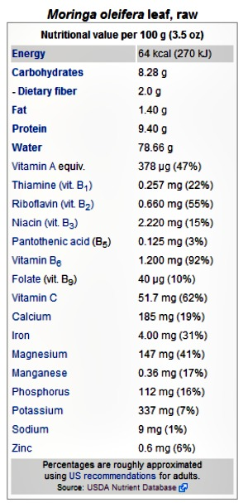  
 Source  
When compared with common foods particularly high in certain nutrients (per 100g) moringa leaves are considerable sources of these same nutrients.

**See chart below for the comparative nutritional value of dried leaves:**

Chart source

Of particular interest to me is the fact that moringa trees have been used to combat malnutrition, especially among infants and nursing mothers. In developing countries, moringa has the potential to improve nutrition, boost food security, foster rural development, and support sustainable landcare.

It may also be used as forage for livestock, a micronutrient liquid, a natural anthelmintic and a possible adjuvant. Moringa has been used in traditional folk medicine, including Siddha medicine and Ayurvedic traditional medicines and in the Philippines.

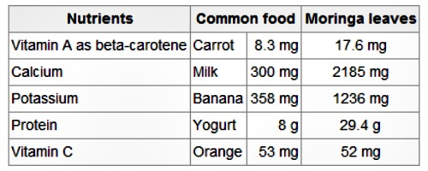

## Introducing Moringa Powder to Your Diet

1. It is recommended that you start slowly with half a teaspoon per day for 3 – 5 days–preferably

with breakfast and ALWAYS with food.

*Moringa powder is strong and may cause side effects such as nausea if taken in too large doses.

2. After 3-5 days you may increase your intake to 1 teaspoon per day which is plenty for a healthy person.

3. After 2 Weeks:

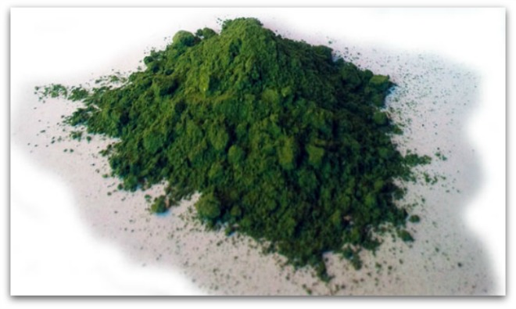

You may want to take moringa every second day after a while listening to your body. You will notice if your dosage is too high. Listen to your body and adjust your usage–just take less, or skip a day -or two.

## Taking Moringa Powder with Food



e

You can take moringa by simply adding it to your food or mixing it with beverages.

If taste is an issue, you can take smaller doses more frequently.

However, you can easily mask half a teaspoon of moringa with fruit, juice and other foods.

**Breakfast**

Take moringa in juice, or mix into your breakfast cereal.

**Salads**

Sprinkle your moringa over wet salad and toss it in with your dressing.

**Cooked Meals**

Sprinkle Moringa powder over the food just before serving. You can stir it in, but DON’T COOK Moringa powder, it diminishes the nutritional value.

**Juice**Add half a teaspoon of moringa to juice.

**Smoothies**Add moringa powder to your smoothies with lemon, honey or dates for sweetness. A full teaspoon will often affect the taste, so go for half a teaspoon.

## Moringa Energy Smoothie

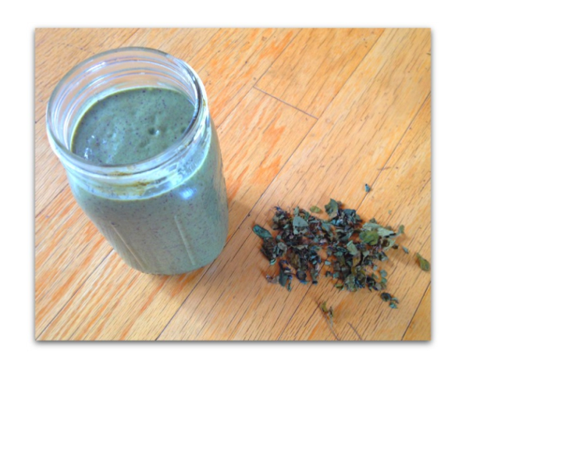

You can make a power packed energizing smoothie by blending moringa with your favorite organic fruits, vegetables and liquids.

## Ingredients

1 teaspoon moringa leaf powder

1 banana 1 cup fresh pineapple chunks

1 /2 cup blueberries

1 orange-peeled

1 cup filtered water or coconut water

*Optional:*

2 tablespoons coconut oil

1/4 avocado – peeled

**Directions:**

Add all of the ingredients to your blender.

Blend until smooth.

Enjoy!

## Moringa Power Shot

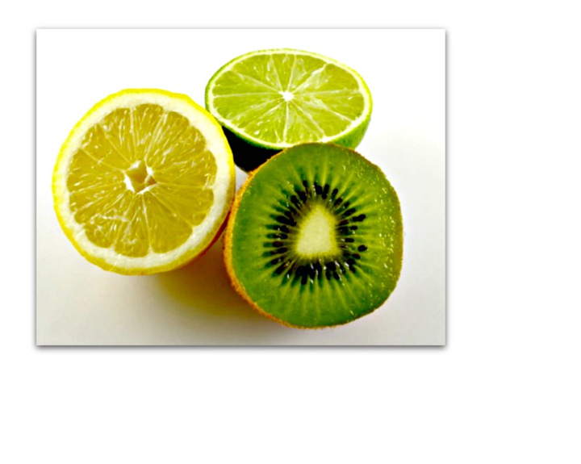

Some moringa users like to down this power shot, first thing in the morning for a quick nutritional shot of energy.

**Ingredients:**

1 teaspoon moringa leaf powder

Half a fresh lemon or lime

Water / Sugar-Free Juice

Optional: Any other juiced berries

**Directions:**

Add a teaspoon of juice to the glass.

Add the moringa powder & stir to create a pulp.

Fill the glass with juice & stir.

Squeeze in the lemon.

Drink immediately.

A few precautions:

**Do NOT:**

Don’t cook moringa powder. Heat above 47 degrees Celsius diminishes many of the nutrients.

DO NOT take too much too soon.

DO NOT take too much moringa on an empty stomach since it a natural laxative. *In the beginning, 1 to 2 teaspoons on an empty stomach should suffice.*

**DO**

Keep your powder dry because moringa can ferment quickly.

Keep moringa powder out of the sun.

Take moringa regularly–since moringa is a food it works best preventatively.

## Important Note:

Like most dark green foods, such as spinach, moringa thickens the blood.

If you are on blood-thinning medication or are pregnant, consult your health care practitioner before taking moringa.

**Possible Side Effects:**

It is important to give your body the time it needs to adapt to moringa to gain the benefits while avoiding possible side effects.

Some side effects have included:

*Nausea:

If moringa makes you nauseous you are taking too much... lower your intake and build up slower, or spread your intake over three meals.

Three days will usually do it.

*Runny Tummy or Laxative

Moringa is very potent laxative–2-3 teaspoons on an empty stomach with water works as a fast acting and natural laxative.

<http://urbannaturale.com/how-to-benefit-from-the-healing-power-of-moringa-plus-a-moringa-superfood-smoothie/>